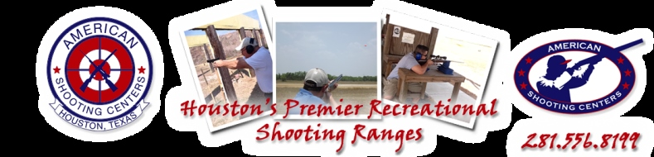

Where: American Shooting Center
16500 Westheimer Parkway
Houston TX 77082

When: April 28, 2017

Start Time: 10:00 am

Includes: 50 Clays, 10 stations
Ammunition
Loaner gun if needed
Lunch
Prize for winning team

Cost: $150.00 per person

Please Sign Up Early to Reserve Spot!

4 person teams (singles will be pared up)

Name | Email | Phone

Please email this completed signup sheet to ron.bertoldi@sealandchem.com

PayPal Link: http://www.stlehouston.com/2HoustonSTLE/Shoot.shtml

Questions, contact Ron Bertoldi ron.bertoldi@sealandchem.com 281-381-8505

